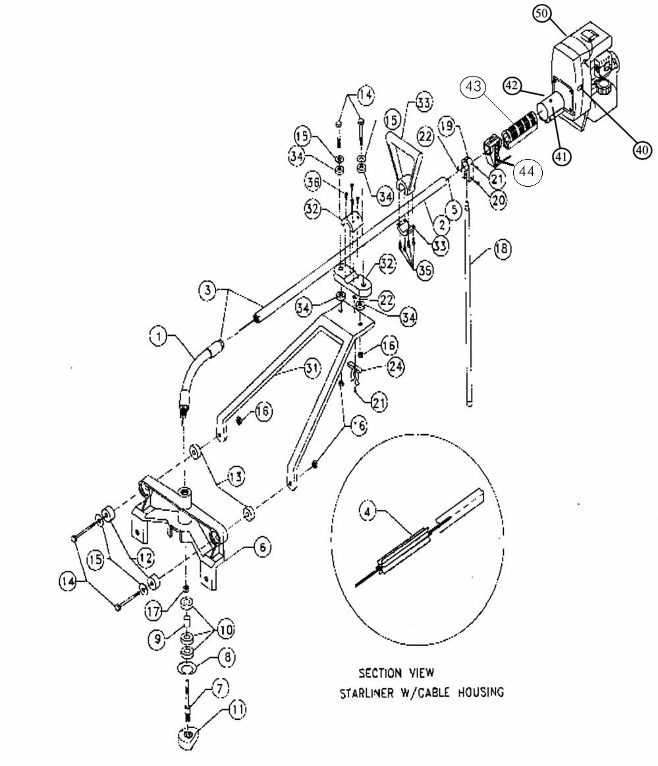
Item# | Item#
TL001 3 ½ x 7/16 Bolt 14  TL010 7/16 x 1 ½ Flat Washer 15  TL012 4 Stroke Engine Adapter Set Screw 3/8 41  TL030 ¾ Rubber Bushing Front 12  TL031 1” Rubber Bushing Back 13  TL032 Frame Connector Bushings 34  TL035 Frame Connector Bushing Set 14-16, 34  2 TL001, 2 TL010, 4 TL032, 2 TL040  TL039 SHCS ¼”-20 x ¾” bolts 35  TL040 7/16” Nut 16  TL042 9/16” Nut 17  TL043 #10 Self Locking Nut 22  TL044 Starliner with Set Screw 4  TL046 5/16” Skt Head Screw 1 ¼” long 36  TL050 Snap Ring 8  TL051 Shaft 7  TL052 Bearings 10  Item#  TL053 Spacer 9  TL054 Honda Cable Adjustment Screw n/a  TL057 Honda Engine Mounting Screws n/a  TL060 Spring Clip 24  TL061 Spring Clip Complete 21,22,24  1 TL060, 1 TL043, 1 TL071  TL070 3/8” Set Screw 21  TL071 Honda Adapter Mounting Screws 21  TL072 1 ½” Screw 20  TL080 Kickstand Bracket Complete 19-22  1 TL072, 1 TL081, 1 TL070, 1 TL043  TL081 Kickstand Bracket 19  TL425 Magnesium Cast Lift Handle 33,35  4 TL309 | TL105 Magnesium Frame w/Spring Clip 21,22,24,31  TL110 Magnesium Frame 31  TL140 Magnesium Frame less Lift Handle 14-16,21,22,  TL035, TL105, TL145 24,31,34  TL145 Magnesium Frame Connector 36  TL155 Magnesium Frame w/Lift Handle 14-16,21,22  1 TL145, 1 TL035, 1TL061, 1 TL425  TL200 Cast Housing w/Sleeve 6  TL250 Cast Housing Complete 6-17  1 TL200, 1 TL299, 2 TL030, 2 TL031  2 TL001, 2 TL010, 2 TL040, 1 TL042  TL299 Eccentric Weight Kit 7-11  1 TL050, 1 TL051, 3 TL052, 1 TL053  1 TL300  TL300 Eccentric Weight 11  TL320 4 Stroke Engine Adapter 41,42 1 TL012  Item#  TL500 Flex Hose 1  TL505 Cable Housing 2  TL515 Cable Housing w/Flex Hose 3  TL525 Cable Housing Complete for Robin 3-5  1 TL515, 1 TL044, 1 TL550  TL525H Cable Housing Complete for Honda 3-5  1 TL515, 1 TL044, 1 TL550H  TL605R Red On/Off Switch 40  TL800 Kickstand 19 TL850 Kickstand Complete 18-22  1 TL800, 1 TL081, 1 TL072, 1 TL070  RT600 Throttle Assembly 44  RT603 Throttle Ajustment Screw n/a  RT630 Rubber Hand Grip 43  EA900H Honda 4 Stroke w/o clutch 50  EA900H/C Honda 4 Stroke w/clutch 50

Throttle Parts List

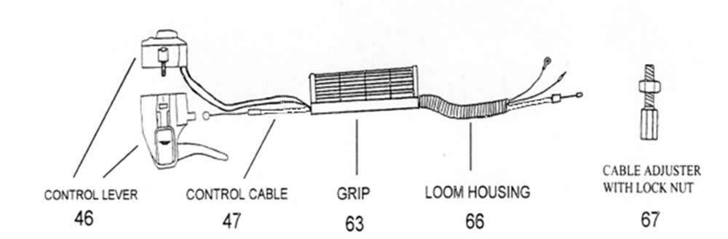

Part# Part Name Item#
RT600 Throttle Assembly Complete n/a
RT603 Cable Adjuster w/Lock Nut 67
RT610 Control Lever 46
RT620 Control Cable 47
RT640 Loom Housing 66
RT630 Grip 63

