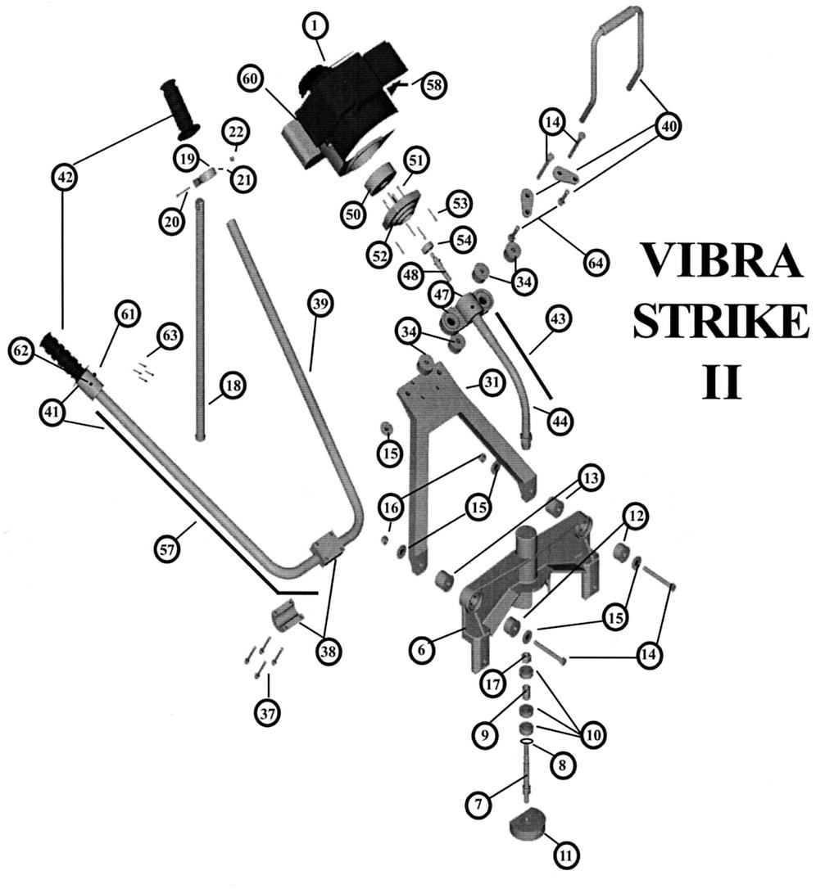
Item # | Item #
TL001 3 ½ x 7/16 Bolt 14  TL006 Dual Handle Bar Connector Screws 37  TL009 Screws for Lift Handle 64  TL010 7/16 x 1 ½ Flat Washer 15 TL012 4 Stroke Engine Adapter Set Screw 62  TL030 ¾ Rubber Bushing Front 12  TL031 1” Rubber Bushing Back 13  TL032 Frame Connector Bushings 34  TL035 Frame Connector Bushing Set 14,15,16,34  2 TL001, 2 TL010, 4 TL032, 2 TL040  TL038 SHCS 10-24 x 1” 63  TL040 7/16” Nut 16  TL042 9/16” Nut 17  TL043 #10 Self Locking Nut 22  TL050 Snap Ring 8  TL051 Shaft 7  TL052 Bearings 10  Item # | TL053 Spacer 9  TL054 Honda Cable Adjustment Screw 58  TL057 Honda Engine Mounting Screws 53  TL070 3/8” Set Screw 21  TL071 Honda Adapter Mounting Screws 51  TL072 1 ½” Screw 20  TL080 Kickstand Bracket Complete 19,20,21,22  1 TL072, 1 TL081, 1 TL070, 1 TL043  TL081 Kickstand Bracket 19  TL110 Magnesium Frame 31  TL140 Magnesium Frame Complete 14,15,16,34  1 TL035, 1 TL110, 1 TL311  TL200 Cast Housing w/Sleeve 6  TL250 Cast Housing Complete 6-17  1 TL200, 1 TL299, 2 TL030, 2 TL031  TL299 Eccentric Weight Kit 7-11  1 TL050, 1 TL051, 3 TL052, 1 TL053,  1 TL300  Item #
TL300 Eccentric Weight 11  TL302 Dual Handle Bar Connector 38  TL303 Dual Handle Bar 39  TL304 Lift Handle for VSII 40  Includes 2 tear drops, 2 TL009  TL306 Grips 42  TL307 Honda Engine Drive Cable 43  TL308 Honda Engine Flex Hose 44  TL309 Screws for Lift Handle  TL311 Honda Engine Frame Connector 47  Includes TL044 (SSS 5/16-18 x 5/16”)  TL316 Honda Clutch Drum 50  TL317 Honda Engine Adapter 52  TL319 Honda Clutch Shaft 48 | TL322 Throttle Cable for Honda Engine 57  TL324 Honda Clutch Complete 48,50-54  Includes TL319, TL316  TL326 Honda Exhaust Deflector with Screw 60  TL328 Honda Throttle Complete 57, 62,63  Includes 1 TL322  TL329 Honda Clutch Bearing 54  TL330 Throttle Thumb Screw 61  TL605 Toggle Switch not shown  TL800 Kickstand 18  TL850 Kickstand Complete 18-22  1 TL800, 1 TL081, 1 TL072, 1 TL070  EA900H Honda 4 Stroke Engine w/o Clutch 1  EA900H/C Honda 4 Stroke Engine w/Clutch 1

