Part # Part Name Qty. Part #

EA900HC Honda 4 Stroke Engine w/clutch 1 1
EA900H Honda 4 Stroke Engine 1 1
RT600 Throttle Assembly 1 2
RL500* Rattler Flex Hose 1 3
RL550* Rattler Drive Cable 1 4
RL250 Rattler Vibrator Head Assembly 1 5
TL650 Shoulder Strap Assembly 1 6

*Rattler flex hose and drive cable can be cut to specified length

We now have a part called the Rattler Whip. This includes part# 3,4, &5. You can use your current Rattler engine and interchange the whips to get the desired length you need for the job!!

Rattler Whip

Part# Description Part# Description

RL304 4’Rattler Whip RL310 10’Rattler Whip
RL305 5’Rattler Whip RL311 11’Rattler Whip
RL306 6’Rattler Whip RL312 12’Rattler Whip
RL307 7’Rattler Whip RL313 13’Rattler Whip
RL308 8’Rattler Whip RL314 14’Rattler Whip
RL309 9’Rattler Whip

Rattler Vibrator Head Assembly

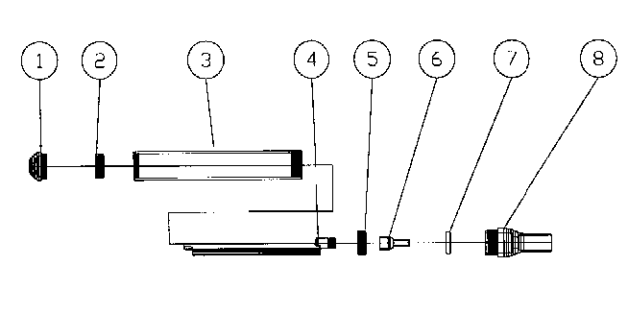

Part# Part Name Item#

RL0015 End Cap 1
RL0025 6003RS Bearing 2
RL0035 Vibrator Shaft Housing 3
RL0045 Vibrator Shaft 4
RL0065 Flex Shaft Connector 6
RL0075 Seal 7
RL0085 Flex Shaft Housing Connector 8
RL250 Vibrator Assembly Complete 1-8
TL052 Vibrator Shaft 202 Bearing 5

Rattler Hose and Cable Lengths

Honda/ Robin

Rattler Robin 4 Stroke 2 Stroke Cable
Length Hose Hose Length
4’ 28.25” 27.25” 40”
5’ 40.25” 39.25” 52”
6’ 52.25” 51.25” 64”
7’ 64.25” 63.25” 76”
8’ 76.25” 75.25” 88”
9’ 88.25” 87.25” 100”
10’ 100.25” 99.25” 112”
11’ 112.25” 111.25” 124”
12’ 124.25” 123.25” 136”
13’ 136.25” 135.25” 148”
14’ 148.25” 147.25” 160”
15’ 160.25” 159.25” 172”
16’ 172.25” 171.25” 184”

When measuring your Rattler hose when assembled, the length of the hose will be about 3 inches shorter than the hose lengths above. This is because about 1 ½” of the hose goes up into the engine end and about 1 ½” goes into the vibrator head. The hose length you measure will help you determine the Rattler Length that you have. You can then just call us and tell us that you need a Honda or Robin Hose for a ?’ Rattler. Example: You measure your hose and find that it is 25.25 inches when assembled. This means you have a 4’ Honda Rattler. When you call and tell us you need a 4’ Honda hose, we will cut the hose to a length of 28.25 inches.

