F4 Float Parts
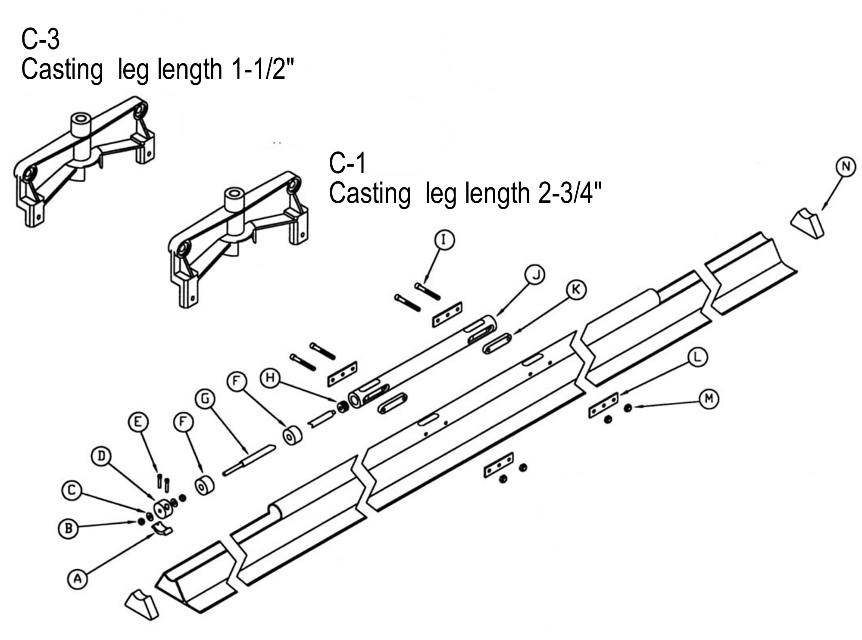

Part# Description Item Reference

FM3026 Triangle Rubber end Molds N
FM3028 Mounting Cylinder End Plug H
FM3031 SHCS ¼-20 E
FM3033 5/16” Flat Washer C
FM3034 3/8”-16 Nylock Nut M
FM3042 Saddle Washer L
FM3044 3/8”-16 x 2 ½” Socket Set Screw I
FM3045 Mounting Cylinder J
FM3048 Hardened Mounting Cylinder Wedge K
FM3049 Upper/Lower Adjusting Stop A&D
FM4508 8’ Adjusting Rod G
FM4510 10’ Adjusting Rod G
FM4512 12’ Adjusting Rod G
FM4514 14’ Adjusting Rod G
FM4508 16’ Adjusting Rod G
TL015 3/8”-16 Flat Head Nut B
TL033 Rubber End Seal F

