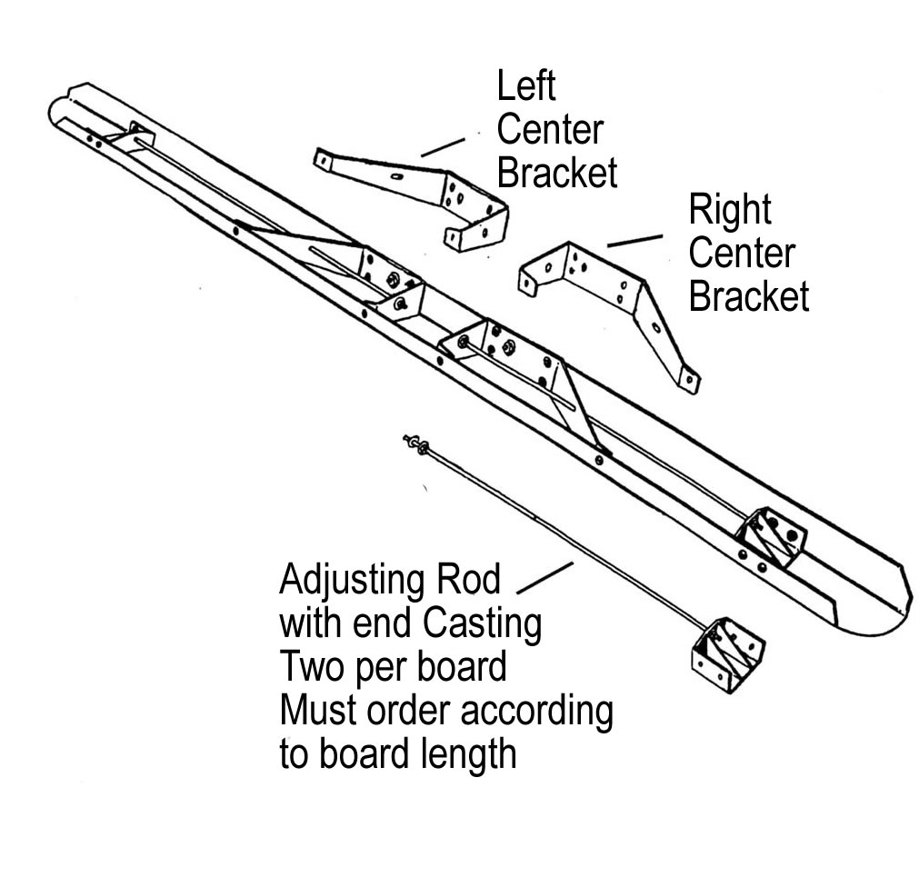
F1 Float Parts
Part# Description

FB250 Left Center Bracket
FB300 Right Center Bracket
FM3020 End Casting
FM3027 Flat Bolt
TL040 Nuts
FB3508 8’ Adjusting Rod W/End Casting
FB3510 10’ Adjusting Rod W/End Casting
FB3512 12’ Adjusting Rod W/End Casting
FB3512 14’ Adjusting Rod W/End Casting
FB3516 16’ Adjusting Rod W/End Casting
FB3518 18’ Adjusting Rod W/End Casting
FB3520 20’ Adjusting Rod W/End Casting
FB408 8’ Adjusting Rod Only

FB400 10’ Adjusting Rod Only
FB412 12’ Adjusting Rod Only
FB412 14’ Adjusting Rod Only
FB408 16’ Adjusting Rod Only
FB400&FB409 18’ Adjusting Rod Only
FB409&FB412 20’ Adjusting Rod Only

